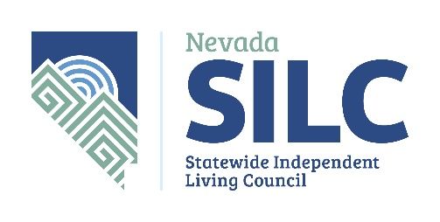
P.O. Box 33386
Las Vegas, NV 89133
nvsilc@adsd.nv.gov
https://www.nvsilc.com/

AGENDA

Name of Organization: Nevada Statewide Independent Living Council (NV SILC) Integrated Workforce Development Subcommittee (IWD)

Date and Time of Meeting: Thursday, February 17, 2022
2:30 p.m.

This meeting will be held via video-conference only:

The public may observe this meeting and provide public comment on Zoom.
To Join the Zoom Meeting
https://us02web.zoom.us/j/9299041434?pwd=NmM5Tk1Od3ltRzg1enhRYTU3WDdUZz09

Meeting ID: 929 904 1434
Password: NVSILC (case sensitive)

+1 253 215 8782 US (Tacoma)
The number provided may incur long-distance telephone carrier charges, and is offered as a regional call-in number, only.
Meeting ID: 929 904 1434
Password: 707401 (if exclusively calling in; if accessing the meeting via both the audio and video feed, please use the above password instead)

Find your local number: https://us02web.zoom.us/u/kdGvZ9R9O5

Meeting Materials Available at: https://www.nvsilc.com/meetings/

- Welcome, Roll Call and Introductions
Dr. Sondra Cosgrove, Subcommittee Chair

- Public Comment
(No action may be taken upon a matter raised under public comment period unless the matter itself has been specifically included on an agenda as an action item. Comments will be limited to three minutes per person. Persons making comment will be asked to begin by stating their name for the record and to spell their last name and provide the secretary with written comments.)

- Approval of Meeting Minutes from 9/28/2021 (For Possible Action).
Dr. Sondra Cosgrove, Subcommittee Chair

- Discussion and Make Recommendations Regarding Heart of Glass Premiere and Panel Discussion in October 2021 (For Possible Action).
Dr. Sondra Cosgrove, Subcommittee Chair

- Discussion and Make Recommendations Regarding South Carolina and California Legislative Initiatives Being Models for Nevada (For Possible Action).
Dr. Sondra Cosgrove, Subcommittee Chair

- Discussion and Make Recommendations Regarding Future Legislation Impacting Integrated Employment in Nevada (For Possible Action).
Tracy Brown-May, Assemblywoman, District 42

- Update Regarding the January 27,2022 Meeting Held by the Community College Workforce Training and Programs Committee.
Dr. Sondra Cosgrove, Subcommittee Chair

- Discussion and Make Recommendations Regarding a Strategic Plan for Workforce Inclusivity (For Possible Action).
Dr. Sondra Cosgrove, Subcommittee Chair

- Discussion and Make Recommendations Regarding any Member Announcements and Upcoming Events (For Possible Action).
Dr. Sondra Cosgrove, Subcommittee Chair

- Approve Next Meeting Agenda Items and Meeting Dates (For Possible Action)
Dr. Sondra Cosgrove, Subcommittee Chair

- Public Comment
(No action may be taken upon a matter raised under public comment period unless the matter itself has been specifically included on an agenda as an action item. Comments will be limited to three minutes per person. Persons making comment will be asked to begin by stating their name for the record and to spell their last name and provide the secretary with written comments.)

- Adjournment
Dr. Sondra Cosgrove, Subcommittee Chair

NOTE: We are pleased to make reasonable accommodations for members of the public who have disabilities and wish to attend the meeting. If special arrangements for the meeting are necessary, please notify Wendy Thornley at (775) 687-0551 as soon as possible and at least five days in advance of the meeting. If you wish, you may email her at wthornley@adsd.nv.gov According to NRS 241.020, supporting materials for this meeting is available at: 3416 Goni Road, #D-132, Carson City, NV 89706 or by contacting Wendy Thornley at (775) 687-0551 or by email at wthornley@adsd.nv.gov.

Agenda Posted at the Following Locations:

Notice of this meeting was posted on the Internet: https://www.nvsilc.com/meetings/ and https://notice.nv.gov

