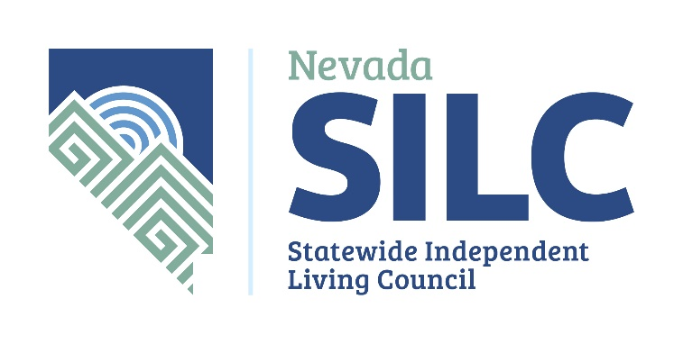

Nevada Statewide Independent Living Council

Notice of Funding Opportunity (NOFO) for Federal Fiscal Year 2022 - Independent Living Partners
October 1, 2021 through September 30, 2022

The Nevada Statewide Independent Living Council (NV SILC) is seeking proposals for subawards to help meet the Council’s goals and objectives listed in the State Plan for Independent Living Federal Fiscal Year 2021 which can be found at www.nvsilc.com .

Council Background
The Nevada Statewide Independent Living Council (NV SILC) is established under Executive Order and exists within the State of Nevada under Federal Mandate: Title VII, Part B of the Rehabilitation Act as amended (Rehab Act). The NV SILC is funded annually by the federal Administration for Community Living (ACL).

The NV SILC accomplishes its federal mandates through several different avenues. Some activities are carried out by Council members and Aging and Disability Services Division staff; others are accomplished by partnering with other established agencies and organizations to address areas of mutual concern. Finally, the NV SILC identifies gaps in service delivery and provides subawards to develop and implement projects that address innovative ways to fill those gaps and develop infrastructure for the State.

These gaps in service are identified through the development of a Three-Year State Plan for Independent Living (SPIL) as outlined in the Rehab Act. The SPIL objectives include Objective 1A: Provide $30,000 in Federal Fiscal Years 22 and 23 (October 1-September 30) for new community services and services with the highest need throughout the State using current data. The Rehab Act allows the Council to determine the areas of emphasis upon which to focus. Each SILC is required to review current needs, services and supports available in their State to determine how their subaward funding will be expended.

Independent Living Definition
Independent living (IL) is a philosophy, a way of looking at society and disability, and a worldwide movement of people with disabilities working for equal opportunities, self-determination, and self-respect.
Independent living means the ability to examine alternatives and make informed decisions and direct one's own life. This ability requires the availability of information, financial resources and peer group support systems. Independent living is a dynamic process, it can never be static.

The Independent Living (IL) movement is committed to fulfilling the following five core services: advocacy, information and referral, independent living skills, peer support and mentoring, and transition (institutional).

Council Initiatives
During this funding period, the NV SILC is specifically looking for projects to help meet the following objectives and outcomes as outlined in the 2021-23 SPIL.

Goal 1: Improve Access to Independent Living Supports and Services.

Objective A1: Provide $70,000 in support Federal Fiscal Year 21 (October 1-September 30), and $30,000 in Federal Fiscal Years 22 and 23 (October 1-September 30) for new community services and services with the highest need throughout the State using current data.
Objective A2: The SILC will fund at least one Part B competitive subgrant for services needed each year. – Grantees will provide the SILC with a quarterly report.

Priorities for this NOFO
- Addressing accessible and affordable housing for people with disabilities in the State of Nevada.
- Addressing accessible and affordable transportation for people with disabilities in the State of Nevada.
- Services for (traumatic and other) brain injury services focused on peer support, research and education.
- Rural services for independent living.
- Transition services for students in Nevada, including personalized guidance and assistance in planning for college.
- Transition services for individuals from institutional settings, where supportive services fall short of the individuals’ immediate needs.

Expected Outcome(s) based on strategies used:
- Housing: increased number of people with disabilities who can obtain affordable and accessible housing as a result of this project.
- Transportation: increased number of people with disabilities who receive affordable and accessible transportation.
- TBI or other brain injury: increased number of people receiving brain injury services.
- Rural IL Services: increased number of people with disabilities who live in rural areas receiving IL services.
- Transition services: increased number of students with disabilities supported through transition services.
- Transition services: increased number of persons with disabilities transitioned from institutions.

SUBAWARD FUNDS AVAILABLE FOR THIS NOFO: Up to $20,000

Funding Information and Procedures
***All questions will be shared and answered publicly on the SILC’s website www.nvsilc.com within 24 hours of having received them.
All questions should be directed to nvsilc@adsd.nv.gov .***

Funding Source
The funding for these projects is from federal Title VII Part B funds. As written within Title VII, Section 705 of the Rehabilitation Act of 1973, as amended by the 1998 amendments (Public law 105-220) (the Act) provides for the establishment of a Statewide Independent Living Council (the Council) consistent with the requirements of the Act. The Council coordinates with the Nevada Aging and Disability Services Division, Planning, Advocacy and Community Services Unit, as the Designated State Entity (DSE) for Independent Living services, to promote a philosophy of Independent Living and empower individuals with disabilities to maximize leadership, economic self-sufficiency, independence, inclusion, and integration into society; and the Council and the DSE coordinate with Aging and Disability Services Division, Planning, Advocacy and Community Services Unit, for the provision of Independent Living services.

Eligibility
Public and private, nonprofit organizations who are section 725 compliant can apply if interested in providing services outlined in this NOFO.

Available funding is allocated to provide new and creative methods of ensuring unserved and underserved populations receive: (1) the independent living services that are needed that do not necessarily fall under all guidelines of the State’s Assistive Technology for Independent Living Program, (2) public education regarding the IL Philosophy, (3) specific service needs for individuals with disabilities, and (4) transition specific training & technical assistance.

Participation requires flexibility to accommodate opportunities and needs throughout the state that otherwise would not be met. Community partners would establish and maintain a close working relationship with the SILC to ensure services are meeting expectations. Prospective SILC partners must have the expertise and structure necessary to provide the IL services and proposals should clearly provide evidence of those capabilities for each IL service included in their proposal. Prospective SILC partners must collect performance measure and survey data for all services provided. Prospective SILC partners must adhere to the ADSD subaward process and will communicate with both the agency and the SILC Executive Director regarding all fiscal matters.

The final funding amount and number of subawards will be determined based on the number of responses received by ADSD, application scoring, regional allocations, and administrator discretion.

Funding is distributed as monthly reimbursements. Subrecipients who require advance funding must thoroughly justify the need within the Application Questionnaire. ADSD may or may not accept the justification and could ask for further information before approving or denying the request. Advance payments are only distributed on a monthly basis and must be reconciled at the conclusion of each month before additional funding will be released.

Budget Period and Reporting Cycle
This competitive process is for a 12-month program beginning October 1, 2021. The subaward budget and reporting period will be October 1, 2021 through September 30, 2022.

Budgetary support for subrecipients is not anticipated beyond September 30, 2023.

General Conditions
- There is an expectation of renewal for one subsequent year.
- The Nevada Aging and Disability Services Division (ADSD) has fiscal responsibility of all SILC funds. As such, all applicants must comply with all ADSD policies and procedures for subawards in addition to the Nevada Statewide Independent Living Council (NV SILC) Subaward Procedures Manual.
  - General Service Specifications provide program standards for all funded programs, unless noted as exempt in the Notification of Subaward (NOSA). The Division has final authority over content. Service Specifications are evolving documents and are available at http://adsd.nv.gov/Programs/Subaward/ServSpecs/Documents/.
  - Requirements and Procedures for Subaward Programs (RPGPs) are statements of ADSD policy that ensure fiscal compliance with statutes, regulations and/or rules. Subrecipients must follow the RPGPs, and pending subsequent regulations, whenever the particular regulation applies to their funded program. The ADSD Requirements and Procedures for Subaward Programs are available at http://adsd.nv.gov/uploadedFiles/agingnvgov/content/Programs/Subaward/FiscalRequirements.pdf.
- Projects must be designed to result in replicable, sustainable systems change by:
  - demonstrating effective approaches to a specific need of the disability population;
  - effecting long term changes in policies and practices; and/or
  - building capacity and/or expanding the scope of effective programs.
- Projects must be driven by the Independent Living Philosophy, where all served individuals are given the opportunity to work together with the SILC or Centers for Independent Living to create an Independent Living goal along with any services received. Training will be provided to all partners regarding the Independent Living Philosophy and how to incorporate it into all services.
- Projects must focus primarily on persons with disabilities, their families and their support networks.
- The NV SILC reserves the right to withdraw the Notice of Funding Opportunity and to accept or reject in whole or in part any or all proposals received, to require modification to any part of accepted proposals, including the budget and the amount requested, and to waive any irregularities in the proposed projects.
- Subawardees must not appear on the Federal Lists of Parties Excluded from Federal Procurement or Non-procurement Programs. The list of disbarred parties can be found on the Internet site at https://www.sam.gov/SAM/.
- Subawardees, if required, must be registered with the Nevada Secretary of State and licensed to do business in the State.
- Council decisions regarding subaward awards are final.

Fiscal Conditions
- Award amounts are subject to the availability of Title VII Part B funds.
- To ensure proper obligation of funds, there is an expectation that all awarded applicants will spend down at least 60% of their award by August 30 of the calendar year in which the subaward was awarded.
- The Nevada SILC will not pay more than 10% for indirect costs or fringe for any award.
- ALL costs listed must be reasonable, necessary, allocable, consistent and allowed under Federal law. Funds may not be used for capital expenditures or to purchase food items.

Submission Procedures
- Deadline: Friday, June 30, 2021.

  - Applications must be emailed to dlyons@adsd.nv.gov.

- Failure to meet the application submission deadline will eliminate the application from consideration in this funding opportunity.

Funding Decisions
- After application acceptance, the SILC Executive Director, Chair, and an ex-officio Council member, will review all applications and make initial funding recommendations based on the scoring matrix on page 6.
- The SILC will review funding recommendations and scores. Reporting and compliance history of previous or current subrecipients will also be reviewed.
- The SILC will consider all input prior to making final funding decisions.
- ADSD may negotiate with or seek additional information from applicants before decisions are made.
- The SILC’s decision is final.
- Subaward announcements will tentatively be released in August.
- Notices of Subaward (NOSAs) will be distributed in August, or as ADSD receives requested subrecipient budget revisions, as applicable.

Scoring Matrix
Competitive applications will be scored according to the following matrix (50-point total):

- Service area, outreach plans and proposed service delivery to target populations (10 points plus 5 bonus points).
- Items are not defined/described and are unrelated to the proposed service – Score 0 points
- Items are all poorly or partially defined/described and/or mostly unrelated to the proposed service – Score between 1 and 4 points
- Items are mostly defined/described, with some areas lacking, and/or partially unrelated to the proposed service – Score between 5 and 6 points
- Items are satisfactorily defined/described and mostly related to the proposed service – Score between 7 and 9 points
- Items are thoroughly defined/described and undoubtedly related to the proposed service – Score 10 points
- Bonus – Rural/frontier, or underserved or unserved service areas – Score 5 bonus points

- Applicant’s capacity to provide the service, its experience and existing or proposed partnerships (10 points).
- No experience and lack of capacity and partnerships – Score 0 points
- Some experience, but lack of capacity and/or partnerships (or vice versa) – Score between 1 and 5 points
- Good experience, but lack of capacity and/or partnerships (or vice versa) – Score between 6 and 9 points
- Exceptional experience, capacity and existing partnerships, with plans to seek new partnerships – Score 10 points

- Other funding, sustainability goals, and reasonableness of cost per client, unit of service and program expenses (10 points).
- No other funding or sustainability goals; unreasonable cost per client, unit of service and program expenses – Score 0 points
- Limited other funding and/or sustainability goals; slightly unreasonable cost per client, unit of service and program expenses with poor expense justification – Score between 1 and 4 points
- Satisfactory other funding and/or sustainability goals; slightly unreasonable cost per client, unit of service and program expenses with poor expense justification (or vice versa) – Score between 5 and 6 points
- Satisfactory other funding and/or sustainability goals; mostly reasonable cost per client, unit of service and program expenses and justification – Score between 7 and 9 points
- Abundant other funding and/or sustainability goals; all costs are reasonable and justified – Score 10 points

- Relevance, achievability and impact of the proposed goals and objectives, as well as evaluation of outcomes (10 points).
- Goals, objectives and evaluation of outcomes are not related to the program, unachievable and do not show impact – Score 0 points
- Goals, objectives and evaluation of outcomes are slightly related to the program, achievable and impactful – Score between 1 and 4 points
- Goals, objectives and evaluation of outcomes are mostly related to the program, achievable and impactful – Score between 5 and 6 points
- Goals, objectives and evaluation of outcomes are adequately related to the program, achievable and impactful – Score between 7 and 9 points
- Goals, objectives and evaluation of outcomes are strongly related to the program, achievable and impactful – Score 10 points

- Adherence to application instructions and accurate completion of forms (5 points).
- Instructions not followed and forms not complete – Score 0 points
- Some instructions followed and some forms not complete – Score between 1 and 2
- Most instructions followed and forms are complete – Score between 3 and 4
- All instructions followed and forms are complete – Score 5 points

Direct Questions To:
Nevada Statewide Independent Living Council
P.O. Box 33386, Las Vegas, NV 89133
Phone: 702-757-7990 (all questions about this NOFO should be directed to email below)
Email: nvsilc@adsd.nv.gov or dlyons@adsd.nv.gov

(continue for application instructions)

APPLICATION FORMAT and FILE INSTRUCTIONS

Application Format
The application MUST conform to the following requirements in order to be considered for funding:

- Applications must be computer-generated (no handwritten or typewriter-produced applications).

- The application must be concise and no more than 35 pages (excluding attachments). Do not include cover sheets, cover letters, unsolicited attachments or application instruction pages, as they will be included in the page limit. Specific page limits are listed next to page names below. If no page limit is listed, the document is one (1) page.

- Applications are expected to be free of spelling and grammatical errors.

- Use black, 12-point Arial font in the application’s Word file. In the Excel file, use the pre-set font settings.

- The application must be submitted on Division forms. The application must be the ADSD Competitive Subaward Application – Nevada Statewide Independent Living version (as shown in the application’s footer).

- Submitted applications must be on white, 8 ½ x 11 size paper, assembled according to the instructions on the Application Checklist on page 14 and saved as a PDF document. Applicants that are not able to submit one file may follow the instructions on the Application Checklist to submit the application in sections.

Application Files
Three (3) files are to be used when completing the subaward application. The submitted PDF application must have all elements of these files included:

- Microsoft Excel File: ADSD Subaward Application- SILC FFY20 Part 1
- Microsoft Word File: ADSD Subaward Application- SILC FFY20 Part 2
- PDF File: DHHS Subrecipient Questionnaire – available at: http://adsd.nv.gov/uploadedFiles/adsdnvgov/content/Programs/Subaward/Applications/SubrecipientQuestionnaire.pdf

- Additionally, applicants must submit attachments as request within the Application Checklist on page 14. Attachments are categorized by “mandatory,” “optional” or “if applicable.”

The Excel file contains the following forms, in order:
- Applicant Information
- Budget Narrative, 8-page limit
- Budget Summary

To access each form in Excel, click on the corresponding tab at the bottom of the page/ workbook as shown here:

If you do not see the tabs at the bottom of the page, maximize the screen by clicking the button on the right side of the screen, as shown here:
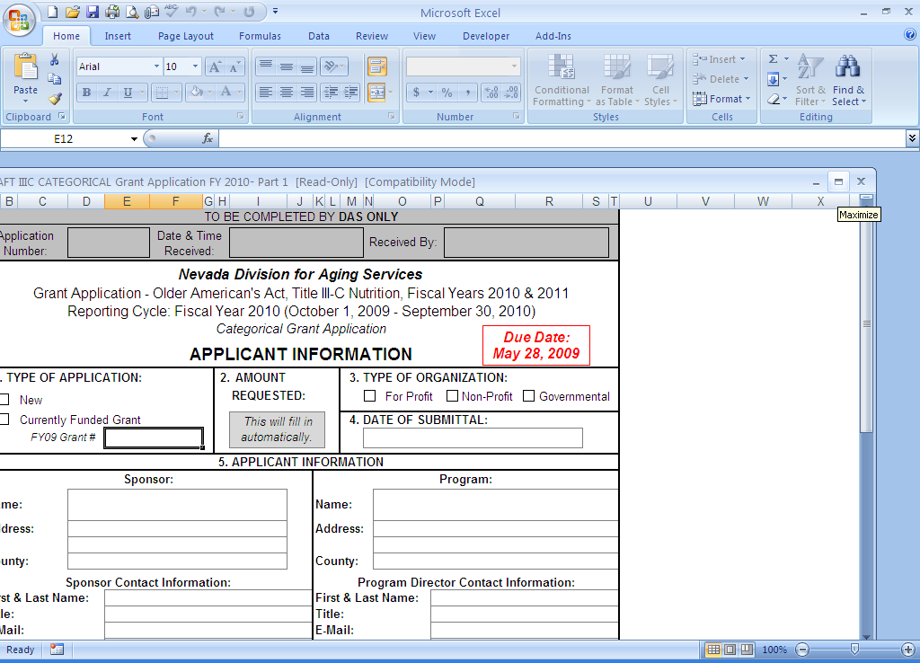

PLEASE NOTE: Do not utilize multiple copies of the Excel file to create your application; there are formulas that carry from page-to-page. For best results, complete each tab of the workbook in order. Additionally, do not paste information from past applications, as it might cause problems with the formulas. This will ensure that invalid error messages are not shown on the application and linked boxes will have a value.

The Word file contains the following forms, in order:

- Project Narrative, 10-page limit
- Goals and Objectives, 3-page limit
- Organizational Standards and Applicant Questionnaire, 3-page limit

The Subrecipient Questionnaire (PDF file) is pre-set at 6 pages. Provide an answer to each question.

Please contact ADSD if you have questions regarding a form, or if the information below for the Excel and Word files does not answer your question.

FORM INSTRUCTIONS – Excel File

APPLICANT INFORMATION

Box # | Instructions
1 | If the agency is not currently funded by ADSD for the proposed service, choose “New Applicant or Type of Service.” If ADSD is currently funding the service, choose “Currently Funded ADSD Subaward” and enter the agency’s FY19 subaward number for that service, which can be located on the FY19 NOSA.
2 | No action required. The amount requested will auto-fill once the Budget Narrative is complete.
3 | Select the agency’s organization type.
4 | Enter Subrecipient and Program information, as requested on the form. Complete both sections. Subrecipients are entities that are responsible for the funds awarded. Additional information on Subrecipients (subawardees) is in RPGPs. Programs are entities that provide service delivery under the subaward. The subrecipient contact and program director must not be the same person for accountability purposes. For non-profit organizations, the Subrecipient contact must be the President of the Board of Directors.  Enter the agency’s Employer Identification Number (EIN) or Federal Tax Identification Number.  Enter the agency’s Data Universal Numbering System (DUNS) Number. All DUNS numbers are 9 digits. To request, look-up or make changes to a DUNS number, go to http://fedgov.dnb.com/webform.
5 | No action required. The funding source has been pre-filled.
6 | No action required. The type of service has been pre-filled.
7 | List the program’s service area(s) for the proposed service, by County.
8 | No action required. The funding source has been pre-filled.
9 | No action necessary. These subawards are categorical.
10 | No action required. The services have been pre-filled.
11 | Read the statement. Enter the name and title of the agency’s authorized representative. Once the authorized representative has reviewed the completed application package, he/she will sign and date the original Applicant Information form. By signing the forms, the representative is stating that he/she has approval from the Subrecipient to sign the forms and verified accuracy of the information within the entire application. ADSD must have on file an official letter authorizing the signer if that person is not the head of the nonprofit board, for-profit agency or public entity, depending on the type of organization.

BUDGET NARRATIVE

The applicant name, subaward and service type will auto-fill from information entered on the Applicant Information page.

Describe program expenses requested from ADSD in the budget categories included in the Budget Narrative using the descriptions below as a guide to describe each category of expense. Be sure to provide a detailed response, explain how each expense is related to the proposed project and identify any one-time costs. Provide calculations where requested and follow the examples. Utilize the RPGPs for rules and regulations on allowable expenses.

THIS TAB IS NOT PROTECTED. Do not delete formulas. Ensure text in each row is visible; expand rows as needed (go to numbered rows on the left side of worksheet and drag the bottom line of the row down when you see your cursor change to , or right click on the row number and choose Row Height to enter a height). Each section has additional rows that you may unhide to utilize. Contact ADSD if you need assistance.

PERSONNEL: Line A: List program and administrative staff (Name, Title, PCN) that will provide direct service under the proposed program and the associated costs to be charged to the subaward, using the column headers as guides. Costs associated with administrative staff providing indirect services may only be included in this section in fixed-fee proposals; otherwise, the expenses may be included as part of the indirect/administrative expense percentage at the end of the Budget Narrative. Place an asterisk (*) beside all new positions. If your agency does not have a Position Control Number (PCN) system, one must be developed to identify each position. Line B, for each position listed: List the fringe benefits provided (FICA, Medicare, vacation, state industrial insurance, unemployment insurance, etc.). Briefly describe the position’s duties as they relate to the funding and program objective.

TRAVEL/TRAINING: Identify in-state and out-of-state travel to be completed during the budget period. The red writing must be replaced with actual trip information, such as the name of a conference, location, etc. Complete the trip expenses and enter justification. If multiple trips are proposed, copy and paste another in-state or out-of-state section into the narrative as stated on the form. Utilize GSA.gov for mileage, per diem and lodging. If lodging exceeds the GSA rate, provide an explanation in the Justification section.

If requesting general in-state mileage for operational purposes, enter the cost in the mileage section below “In-State Travel,” provide an explanation of the cost calculation and the reason for travel.

OPERATING: Include SPECIFIC facility and vehicle costs associated with the proposed program (not the agency as a whole), such as rent, maintenance expenses, insurance (split by type), fuel, as well as utilities such as power, water and communications (phone/internet). Also list tangible and expendable personal property such as office supplies, program supplies, necessary software, postage, etc. Provide a calculation for each line.

EQUIPMENT: List equipment to purchase or lease, which cost $5,000 or more (per item), and justify these expenditures. Also list any computers or computer-related equipment to be purchased regardless of cost. Equipment items that cost less than $5,000 should be listed under Operating. Justify the need for these items. There is no guarantee that ADSD will have funds available for equipment.

CONTRACTUAL/CONSULTANT SERVICES: Explain the need and/or purpose for the contractual and/or consultant service. Identify and justify these costs. Only include costs for which there is a written contract or agreement that can be presented to ADSD, if requested.

OTHER: Identify and justify all other expenditures that cannot be identified within another category. These costs may include any relevant expenditure associated with the project. These costs are to be included only if they are associated exclusively with this program. If they are associated with multiple sources of funding, the costs are to be included in Administrative Expenses. Follow the example on the form.

ADMINISTRATIVE/INDIRECT EXPENSES or FEDERAL INDIRECT COST RATE (FICR): Administrative/indirect expenses and FICR are to be used to help cover expenses that are not easily assignable to a specific program or unit within an organization. These costs are associated with depreciation and use allowances, facility operation and maintenance, general administrative expenses such as accounting, payroll, legal and data processing, and any personnel not providing direct services to the project. If requested, the expenses are limited to the maximum rate listed, depending on the funding source and existence of an FICR percentage of the direct project costs requested from ADSD. Administrative/indirect expenses do not apply to equipment or fixed-fee subawards. Reference the Requirements and Procedures for Subaward Programs (RPGPs) GR - 20*. Modified Direct Costs (rate of 10%) must be based upon expenses as outlined within the RPGPs. FICR amount must be based upon allowed expenses per your organization’s current FICR letter. Attach a copy of your FICR letter to the application, as applicable.

BUDGET SUMMARY

The applicant name, subaward and service type will auto-fill from information entered on the Applicant Information page.

This page offers a summary of the subaward budget, match and other funding, as applicable. Information entered into the Budget Narrative will populate the ADSD Funds column. Applicants will enter other funding information in the orange cells.

Matching Funds Requirements: Match is NOT required.

Other Funding: In the columns after Match, enter any other funding that will be used to support the proposed service. Enter the name of the funding source where indicated, whether the funding is pending or secured, and the amount to be used towards the program. Then, break out the funding into the budget expense categories.

Ensure all boxes on row 21 are zero as stated in the row header.

Add comments to box B, if needed. Box C is pre-filled to indicate there is no match requirement. In box D, list potential/estimated amounts and sources of program income. Refer to the RPGPs for information on program income.

FORM INSTRUCTIONS – Word File

PROJECT NARRATIVE
Provide detailed, but concise responses to each section of the project narrative using guidance below and throughout this document. Page Limit: 10 pages

    - Proposed Intervention
Describe clearly and concisely, how your organization plans to carry out the requirements of this program. Include a description of specific activities planned, and any anticipated challenges or technical assistance needs.

    - Target Population and Service Area
Describe the population(s) to be served, specifically any underserved populations. Identify methods to reach the population(s) to be served. Describe in detail if/how services will be brought to rural Nevada.

    - Organizational Capacity and Partnerships
Describe the organization’s capability to perform the proposed services. Include past experiences or anticipated increased capacity as a result of this funding. Describe the professional staff and specific responsibilities under this service and the facilities and other resources in place to support this service. Identify key partnerships and describe in detail how they will enhance services under this program.

    - Cost-Effectiveness and Sustainability
Describe resources outside ADSD funding to be used to support this service. How will these resources be used to enhance services?

    - Evaluation
Describe the methods, techniques, and tools that will be used to measure outcomes and effectiveness of proposed service.

GOALS AND OBJECTIVES

Describe the goals and objectives for this project, including major activities and outcomes. Page Limit: 2 pages

Example entry:
Objective | Activities | Outcomes
- Deaf people and those who are hard of hearing receive training on equipment and relay services. | - Identify hospital partners to host trainings.  - Conduct training 4 x per year at selected partner hospitals. | - 90% of individuals trained will report increased usage of Relay Services.

ORGANIZATIONAL STANDARDS and APPLICANT QUESTIONNAIRE

Read the form and respond accordingly. Page Limit: 3 pages.

On question 3, choose the organizational structure of the agency and identify the governing body or ownership as applicable to the selection. Non-profit agencies must verify information for their board of directors.

APPLICATION CHECKLIST

If you are submitting one PDF file (preferred), assemble the application in the order shown below. You may also submit a PDF for each of the three files (Part 1, Part 2, Subrecipient Questionnaire) and the attachments.

If any of the following items are incomplete or missing, the application will be rejected:

Applicant Information (Excel Document)
Budget Narrative (Excel Document)
Budget Summary (Excel Document)
Project Narrative (Word Document)
Goals and Objectives (Word Document)
Organizational Standards and Applicant Questionnaire (Word Document)
Subrecipient Questionnaire (PDF Document)

Attachments – If included, will not count towards page limit.
Contracts or Memorandums of Understanding (if applicable)
Current Federal Indirect Cost Rate (FICR) Letter (if applicable)
Official letter authorizing a person other than the head of the nonprofit board, for-profit agency or public entity (depending on the type of organization) to sign the application and/or subaward documents (if applicable). See requirements on page 9 regarding authorized signers.

